This village is losing its library - and now possibly its school
By Samantha Craggs, CBC News Posted: Feb 14, 2014 7:08 AM ET Last Updated: Feb 14, 2014 8:36 AM ET
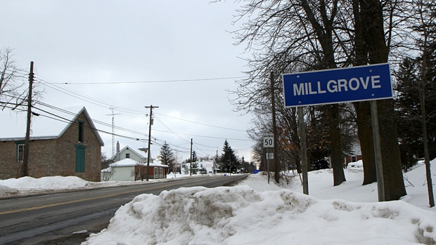
Millgrove, a village off Highway 6 in Flamborough, will lose its library branch this fall. Now a committee has recommended that the board close its only school. (Samantha Craggs/CBC)

Facebook | Twitter | Reddit |  | Share | Email
It’s not an easy year for the village of Millgrove. Its library branch will close this fall, and now an accommodation review team has recommended closing the only school.
The Hamilton-Wentworth District School Board is reviewing the west Flamborough area — which includes Spencer Valley, Millgrove, Greensville, Beverly Central and Dr. John Seaton elementary schools.
School supporters were surprised this month when the citizen accommodation review committee (ARC) struck by the board recommended closing Millgrove, Greensville and Spencer Valley and building a new 525-student school on the Spencer Valley site.
It also recommended closing Beverly Central and Dr. John Seaton and building a new school on the Beverly Central site.
'You can't do that to a community.'- Coun. Judi Partridge
The Millgrove decision is a double shock for the Flamborough community that contains only a school, a library, a general store, a United Church and three child care centres nested around the school.
The school and the library serve as meeting places, and are integral to the fabric of the village, said Coun. Judi Partridge of Ward 15.
“The school becomes part of the reason for being for that community," she said.
The library is also an “essential service” for Millgrove, said Partridge, who was elected after the decision to close the branch. And the spectre of school closure is even worse.
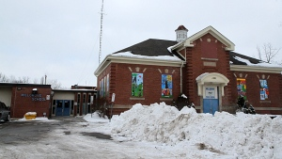
An accommodation review committee has recommended that the board close Millgrove Elementary School. (Samantha Craggs/CBC)
“You can’t do that to a community."
The board struck the accommodation review last year as part of a sweeping review of 22 elementary schools. It came a year after a decision to close eight high schools.
There are still more steps before trustees make a decision on Millgrove. Board staff will spend the next few weeks examining the ARC recommendation, and make its own recommendation to trustees this spring, said Daniel Del Bianco, the board’s senior facilities manager.
The community will have 60 days to give feedback, and then trustees will make a decision.
Board staff could disagree with the ARC recommendation, but that’s only happened once in recent memory. In the 2012 reviews, there was only one case of board staff disagreeing with the ARC, Del Bianco said.
Population of Millgrove Elementary School
Capacity: 227
2012: 183 (81 per cent capacity)
2013: 178 (79)
2014: 177 (78)
2015: 171 (75)
2016: 175 (77)
2022: 166 (73)
A school takes on higher importance in a community like Millgrove, said Jackie Parry, whose daughter goes to the school.
“It’s a central part of the community,” she said. “It’s a beautiful rural school.”

The amalgamation link
Parry lives in Freelton. If Millgrove closes, she said, her daughter will be on the bus for as long as an hour in either direction. These hardships hit a nerve in Flamborough, where residents are still upset about Hamilton’s 2001 amalgamation.
“People have a hard time separating the two," she said. "They are still related in the minds of people here.”
As for the library, Millgrove’s branch will close this fall in favour of an expanded branch in Waterdown. Construction on the $7-million project on Dundas Street East will finish in November, said Karen Anderson, Hamilton Public Library's director of public service.
The Millgrove branch is only open 17 hours a week, Anderson said. And it is too hard to make the 12,000-square-foot building accessible.
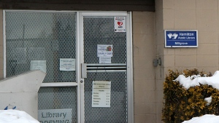
The Millgrove branch of the Hamilton Public Library had 20,000 transactions in 2013, compared to half a million at the Turner Park branch. (Samantha Craggs/CBC)
The Millgrove branch saw 20,000 transactions in 2013, compared to 500,000 at the Turner Park branch. The Millgrove branch is staffed by one part-time employee.

Deterring young families
With the Waterdown branch, “I do feel confident that residents in Millgrove will be able to access great library service,” she said.
“I do acknowledge that it won’t be across the road, and I do understand that will feel like a loss. But we’re hoping that the level of service and the new facility sort of makes up for that piece.”
Kathy Hwang owns the Millgrove General Store. She doesn’t have any children in Millgrove school, and she doesn’t use the library.
But she still worries that young families won’t move there anymore if the school and library both close.
“It’s the start of changing the generation here,” she said.
Other Hamilton schools on the chopping block
The west Flamborough study is just one of four ARCs happening in Hamilton. Here are the other recommendations:
Central Mountain: 1. Close George L. Armstrong in June 2015, with some students going to Queensdale for kindergarten to Grade 6, while students in Grade 7 and 8 from Eastmount Park will go Franklin Road. Queensdale Grade 7s and 8s will attend a renovated Linden Park. 2. Close Ridgemount in June 2015 and its students will go to Linden Park or Pauline Johnson and Cardinal Heights. 3. Build a new 650-student school to replace Cardinal Heights. A second recommendation involves closing Linden Park and Eastmount Park.
East Hamilton: 1. Close Parkdale, Rosedale, Roxborough Park, Viscount Montgomery and Woodward schools. 2. Leave Hillcrest and W. H. Ballard open. 3. Build a new school on the Viscount Montgomery site. The committee also submitted a second option of closing Parkdale and Roxborough Park schools and leaving the rest open.
West Glanbrook: 1. Close Bell-Stone Elementary, which has 55 students, this June and move the students to Mount Hope Elementary

