**[cpe_TO](http://www.twitter.com/)** [**Save our Schools**](http://www.facebook.com/) **Toronto** [**campaignforpubliceducation.ca**](http://www.campaignforpubliceducation.ca/)



**Our Conclusion**

This Program, including each of the 10 points, are urgently required:

* to protect Toronto’s publicly financed school system;
* to maintain a viable education system which functions as an “education model”, rather than as a business model,
* to prevent privatization in any form, and
* to give each student what they need to succeed.

**Campaign for Public Education** is an open assembly of public education advocates designed for exchange, coordination & advocacy. Since 2002 we have campaigned to rebuild Toronto’s publicly-funded education system. We welcome delegates from groups representing parents, ethno-racial communities, students, adult learners, teachers, education workers, school trustees, city councilors, neighborhoods, early childhood educators, social planners & researchers.

**a 10-point program**

**for education**

**in Toronto**

**GIVE ALL OUR STUDENTS WHAT THEY NEED TO SUCCEED**



Following the 1998 amalgamation of school boards, Trustees lost the ability to determine local needs and, to tax in order to fund them.

Previously Toronto’s seven school boards did NOT have constant year over year financial crises.

However, when the province took over complete control of funding, the serious and serial problems began.

Right now, Ontario spends the lowest rate in Canada on education, claiming the province isn’t able to do anything about underfunding because “the deficit must be paid down first”.

Key economists disagree, observing that Ontario has a revenue problem, not a deficit problem.

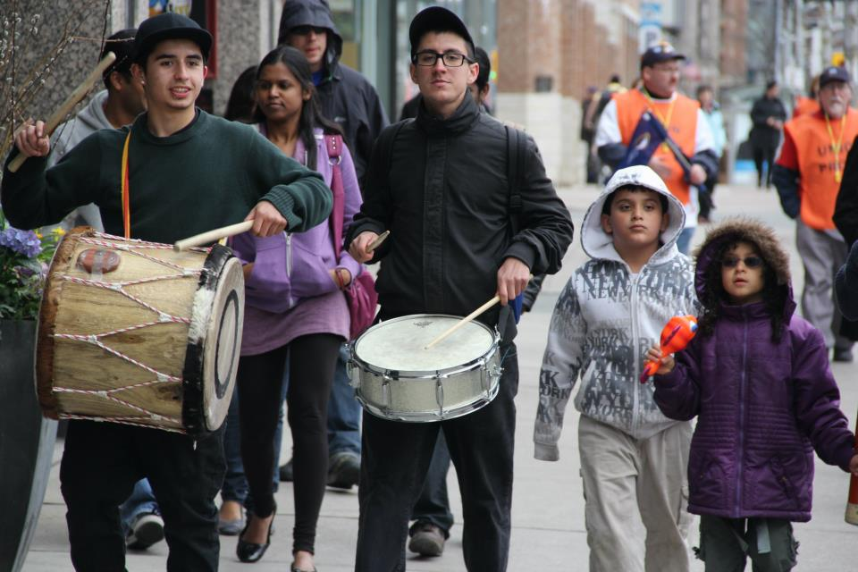

**A 10-point Program for Education in Toronto**

A major infusion of public funding is needed and could be secured by bringing revenues back up to the pre-2009 tax rate. This would begin to restore a level of fairness to Ontario’s taxation system. Then, to protect, renew, restore, and to give all students what they need to succeed, Toronto’s public education system will require:

* **NEIGHBOURHOOD SCHOOLS:** Ensuring that all local neighbourhoods have well-maintained schools, the hubs of their communities, providing programmes and services for all -from young children through to adults and seniors- and valuing parent and community involvement and input.
* **EQUITY:** Providing equity and access to education from early childhood through adult re-training and education, including affordable seniors’ program.
* **RENEWED ROLE FOR TRUSTEES:**  Restoring the role of democratically elected trustees as representatives, advocates and spokespersons for the community as a whole, and responsible for transparent policy, human resources, bargaining and budget decisions of the Toronto Board.
* **FULL DAY KINDERGARTEN:** Extending full day kindergarten to all schools so that there is full day before & after school care, year round “seamless” play-based learning for Junior & Senior Kindergarten students.
* **SMALL-SCALE DELIVERY:** Ensuring there is support for small schools, small classes and small adult/student ratios in all classes, as has been supported by current research.
* **SPECIAL EDUCATION:**  Guaranteeing that there is sufficient staffing and resources to meet the needs of all special needs students and their families.
* **“WHOLE CHILD” LEARNING MODEL:** Ensure teaching of the “whole child” and student by replacing standardized testing with skills such as critical thinking leading to “lifelong-learning”.
* **ADULT EDUCATION:** Providing a fully funded, robust adult education system with credit secondary school courses & non-credit courses including English as a 2nd Language, LINC, Literacy & Basic Skills, Native Languages, Citizenship, Parenting & Family Literacy programs, affordable & accessible seniors’ & General Interest programs.
* **CURRICULUM:**  Restoring and renewing a well-rounded curriculum that includes the arts, trades, physical/health education, libraries, nutrition education, the environment, etc, taught by trained / certified staff.
* **BUILDINGS:** Restoring school buildings by providing adequate staffing and capital repairs so that all schools will be safe, clean, and well-maintained.



Organization

Primary Business Address

Your Address Line 2

Your Address Line 3

Your Address Line 4

Phone: 444-444-4444

Fax: 444-444-4444

Email: xyz@microsoft.com

BUSINESS NAME

### Secondary Heading

The most important information is included here on the inside panels. Use these panels to introduce your organization and describe specific products or services. Ts text should be brief and should entice the reader to want to know more about the product or service.

You can use secondary headings to organize your text to make it more understandable to the reader.

Business Name

Street Address

City, State 00000

Business Name

Street Address

City, State 00000

Address Correction Required

### Secondary Heading

You can use secondary headings to organize your text to make it more understandable to the reader.

Lorem ipsum dolor sit amet, consectetuer adipiscing elit, sed diem nonummy nibh euismod tincidunt ut lacreet dolor et accumsan et iusto odio dignissim qui mmy nibh euismod tincidunt ut lacreet dolore magna aliguam erat volutpat.

### Secondary Heading

The most important information is included here on the inside panels. Use these panels to introduce your organization and describe specific products or services. Ts text should be brief and should entice the reader to want to know more about the product or service.

Lorem ipsum dolor sit amet, consectetuer adipiscing elit, sed diem nonummy nibh euismod tincidunt ut lacreet dolor et accumsan et iusto odio dignissim qui mmy nibh euismod tincidunt ut lacreet dolore magna aliguam erat volutpat.

Lorem ipsum dolor sit amet, consectetuer adipiscing elit, sed diem nonummy nibh euismod tincidunt ut lacreet dolor et accumsan et iusto odio dignissim qui mmy.nibh euismod tincidunt ut lacreet.

Event Schedule

This is where you provide a description of your special event. In addition to listing the dates, times, location, fees, and speakers or sponsors for your event, you can indicate whether registration is required.

Consectetuer adispiscing elit, sed diem nonu, quis nostrud exerci tuition ullamcorpert elit, sed diem nonummy nibh euismod.

**Name**

Description of sponsor or Speaker goes here.

**Name**

Description of sponsor or Speaker goes here.

**Name**

Description of sponsor or Speaker goes here.

**Name**

Description of sponsor or Speaker goes here.

**Name**

Description of sponsor or Speaker goes here.

**Name**

Description of sponsor or Speaker goes here.

Price List

This is where you list what you current event prices are.

**List your product or 0.00   
service here**

Include description if necessary.

**List your product or 0.00   
service here**

Include description if necessary.

**List your product or 0.00   
service here**

Include description if necessary.

**List your product or 0.00   
service here**

Include description if necessary.

**List your product or 0.00   
service here**

Include description if necessary.

**List your product or 0.00   
service here**

Include description if necessary.

Blank Table

This is where you text in a table format if necessary.

|  |  |  |  |
| --- | --- | --- | --- |
| **1** | **2** | **3** | **DESCRIPTION** |
|  |  |  |  |
|  |  |  |  |
|  |  |  |  |
|  |  |  |  |
|  |  |  |  |
|  |  |  |  |
|  |  |  |  |
|  |  |  |  |
|  |  |  |  |
|  |  |  |  |
|  |  |  |  |
|  |  |  |  |
|  |  |  |  |
|  |  |  |  |
|  |  |  |  |
|  |  |  |  |

Primary Business Address

Your Address Line 2

Your Address Line 3

Your Address Line 4

Phone: 444-444-4444

Fax: 444-444-4444

Email: xyz@microsoft.com

BUSINESS NAME

### Secondary Heading

You can use secondary headings to organize your text to make it more understandable to the reader.

Lorem ipsum dolor sit amet, consectetuer adipiscing elit, sed diem nonummy nibh euismod tincidunt ut lacreet dolor et accumsan et iusto odio dignissim qui mmy nibh euismod tincidunt ut lacreet dolore magna aliguam erat volutpat.

Lorem ipsum dolor sit amet, consectetuer adipiscing elit, sed diem nonummy nibh euismod tincidunt ut lacreet dolor et accumsan et iusto odio dignissim qui mmy nibh euismod tincidunt ut lacreet dolore magna aliguam erat volutpat.

Primary Business Address

Your Address Line 2

Your Address Line 3

Your Address Line 4

Phone: 444-444-4444

Fax: 444-444-4444

Email: xyz@microsoft.com

Organization Name

Sign-up Form

|  |  |  |  |  |  |  |  |  |  |
| --- | --- | --- | --- | --- | --- | --- | --- | --- | --- |
| ***Sign up for:*** | | | | ***Time*** | | |  | ***Price*** | |
| ❒ | Type the event name here | | | 00:00 | | |  | 0.00 | |
| ❒ | Type the event name here | | | 00:00 | | |  | 0.00 | |
| ❒ | Type the event name here | | | 00:00 | | |  | 0.00 | |
| ❒ | Type the event name here | | | 00:00 | | |  | 0.00 | |
| ❒ | Type the event name here | | | 00:00 | | |  | 0.00 | |
| ❒ | Type the event name here | | | 00:00 | | |  | 0.00 | |
|  | | | | | | | | | |
| Name | | | | | | | | | |
| Address | | | | | | | | | |
|  | | | | | | | | | |
|  | | | | | | | | | |
| Phone | | | | | | | | | |
| ***Method of Payment:*** | | | | | | | | | |
| ❒ | Check | ❒ | MasterCard | | | | | |
| ❒ | Bill Me | ❒ | American Express | | | | | |
| ❒ | Visa |  |  | | | | | |
|  | | | | | | | | |
| Credit Card No. | | | | |  | Expire Date | | |
| Signature | | | | | | | | |

Primary Business Address

Your Address Line 2

Your Address Line 3

Your Address Line 4

Phone: 444-444-4444

Fax: 444-444-4444

Email: xyz@microsoft.com

Organization Name

Questionnaire Form

|  |  |  |  |  |  |
| --- | --- | --- | --- | --- | --- |
| Briefly describe your desired feedback. | | | | | |
| ***First Question:*** | | | ***Third Question:*** | | |
|  | ❒ | Answer A |  | ❒ | Answer A |
|  | ❒ | Answer B |  | ❒ | Answer B |
|  | ❒ | Answer C |  | ❒ | Answer C |
| ***Second Question:*** | | | ***Fourth Question:*** | | |
|  | ❒ | Answer A |  | ❒ | Answer A |
|  | ❒ | Answer B |  | ❒ | Answer B |
|  | ❒ | Answer C |  | ❒ | Answer C |
|  | | | | | |
| ***Comments:*** | | | | | |
|  | | | | | |
|  | | | | | |
| Name | | | | | |
| Address | | | | | |
|  | | | | | |
|  | | | | | |
| Phone | | | | | |

Primary Business Address

Your Address Line 2

Your Address Line 3

Your Address Line 4

Phone: 444-444-4444

Fax: 444-444-4444

Email: xyz@microsoft.com

Organization Name

Order Form

|  |  |  |  |  |  |  |  |
| --- | --- | --- | --- | --- | --- | --- | --- |
| ***Item # Description Qty. Price Subtotal*** | | | | | | | |
|  | | | | | | | |
|  | | | | | | | |
|  | | | | | | | |
|  | | | | | | | |
|  | | | | | | | |
| Order total: | | | | | |  |  |
| Tax: | | | | | |  |  |
| Shipping: | | | | | |  |  |
| Total: | | | | | |  |  |
|  | | | | | | | |
| Name | | | | | | | |
| Address | | | | | | | |
|  | | | | | | | |
|  | | | | | | | |
| Phone | | | | | | | |
| ***Method of Payment:*** | | | | | | | |
| ❒ | Check | ❒ | MasterCard | | | | |
| ❒ | Bill Me | ❒ | American Express | | | | |
| ❒ | Visa |  |  | | | | |
|  | | | | | | | |
| Credit Card No. | | | |  | Expire Date | | |
| Signature | | | | | | | |

