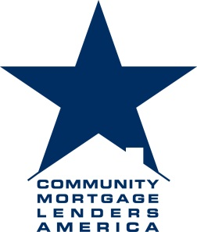

Director of Membership Recruitment
Community Mortgage Lenders of America, Inc.

The Community Mortgage Lenders of America is searching for a proven mortgage sales professional interested in spearheading a national membership recruitment campaign in order to grow the Association’s membership base fourfold.
Director of Membership Recruitment: Identify and successfully recruit and retain members that fit the Association standard as an independent community lender.
Duties: Work with existing management to include Executive Director, Legislative and Legal Staff, and Board of Directors to implement marketing strategies that will result in significantly growing the organization.
Establish monthly and quarterly objectives that will target specific geographic and congressional regions as identified by the legislative team in concert with the membership committee.
Maintain a national presence of the organization through the attendance and participation of programs, conferences and other workshops where mortgage banking and community banking professionals will participate.
Maintain professional and technical knowledge of the industry by participating in programs along-side professional colleagues and prospects.
Participate and contribute to the overall industry leadership team effort by being collaborative and accomplishing related results as needed.
Skills / Qualifications: Seasoned community lender / banker, or wholesale/correspondent rep or executive with a minimum of 5 years of related sales and industry experience. A proven networker and relationship builder that will passionately represent the interests of the community lender while increasing membership within the organization. The Director will report results on a monthly and quarterly basis. Travel will be required. Compensation will be competitive with results based incentives.
Contact: Kevin M. Cuff ~ Executive Director: kmcuff@thecmla.com; www.thecmla.com

The Community Mortgage Lenders of America (CMLA) was founded out of concern that emerging federal policies threaten to severely diminish community based lending, while increasing concentration among the nation's largest financial institutions, to the detriment of competition and consumers. CMLA members include community banks and non-banks who survived the mortgage crisis because of close
attention to prudent and traditional underwriting standards with a strong commitment to sound lending.
-
CMLA Administration Offices | TWO SIXTY FIVE BEACON STREET | ANDOVER, MA 01810 | 978-239-5612 WWW.THECMLA.COM

